Drilling Pipe Maintenance Instructions
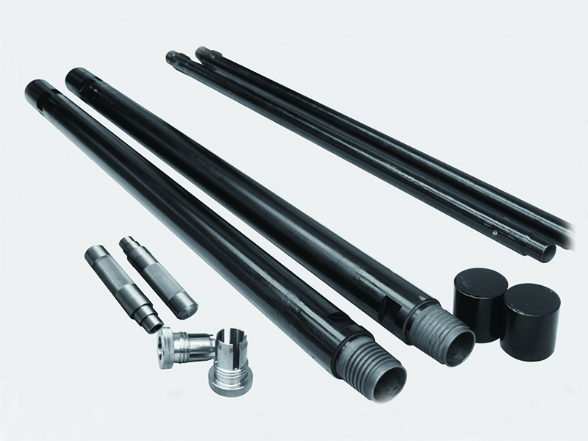

1.When the new drill pipe is used for the first time, the protective grease on the drill pipe thread should be wiped clean, and the inner wall of the drill pipe should be cleaned with air or water, and then the screw oil should be applied to the internal and external thread of the drill pipe to prevent damage to the thread or adhesion.
2.When drilling holes, try to ensure that the holes are vertical to avoid premature wear of drill pipe caused by deviation or bending of the holes.
3.The starting rod should be connected between the impactor and the first drill pipe, otherwise premature damage to the first drill pipe may occur.
4.When connecting the drill pipe each time, remember to apply screw oil to the drill pipe thread, and tighten the drill pipe;If the screw thread is not tightened, the screw thread connection becomes loose, resulting in the top of the grinding teeth becoming sharp, resulting in screw thread damage or adhesion phenomenon;If it is not tightened, the steps of the female button are not pressed tightly, leading to air leakage, and in serious cases, leading to fatigue fracture of the root thread of the male joint.
5.When connecting the drill pipe, the male button should not collide with the shoulder and thread of the female button, and ensure that the male and female joints are aligned, and cannot be forced to buckle if they are not aligned.Ensure the coaxiality of the power head spindle and the connecting drill pipe.
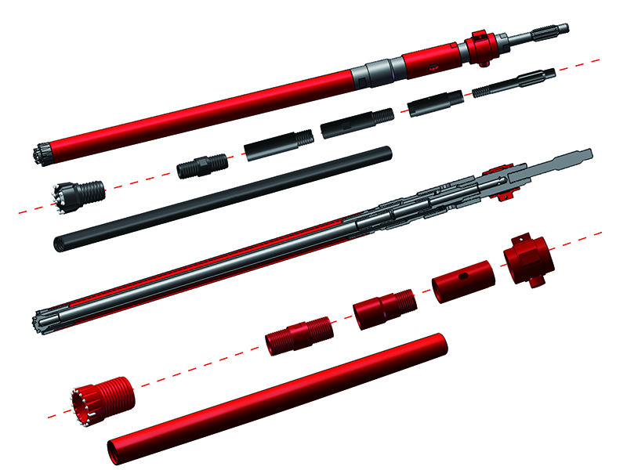

6.Check the wear of each part of drill pipe, and find out the cause of abnormal wear in time:
(1) Whether sharp hard objects (or hard rock edges) scratch the drill pipe in the hole.When the scratch depth of drill pipe body part is less than 0.5mm and is more than one circle of circumference (spiral), please use with caution;When the scratch depth is ≥0.5mm, it is forbidden to use it to avoid greater loss caused by drill pipe fracture.
(2) Drilling pipe wear or deformation caused by deflection, bending and hole wall collapse.
(3) Drill pipe damage caused by construction in abnormal stratum such as pebble layer, fracture layer and reinforced cement layer.
7.The following conditions are normal wear, pay attention to timely replacement of drill pipe:
(1) Uniform and smooth wear on the outside surface of the drill pipe joint or rod, and the outer diameter is less than the standard size 2mm after wear;
The male and female joint thread uniform smooth wear, tooth tip was pointed.
8.Can not be mixed with different manufacturers of drill pipe, to prevent adhesion or thread premature wear, because each manufacturer manufacturing drill pipe technical parameters, processing methods, tools, processing equipment accuracy is different, thread tolerance, close distance, etc., will not be the same.
9.Do not mix drill pipes with large difference between old and new or large difference in wear degree to avoid construction risks.
10.When it is difficult to unshackle the drill pipe, gently vibrate the joint thread with a small hammer. It is strictly forbidden to use a sledgehammer to violently knock the joint, resulting in deformation and damage of the thread.
11.It is found that the drill pipe thread has a small local range of damage (about 1-2 buttons, buckle length 10mm), should be repaired with the file before use.
12.The drill pipe should be avoided long-term open storage. Before storage, the drill pipe should be cleaned, rust-proof grease should be smeared on the thread part, and protective caps should be worn.When handling drill pipe, avoid impact damage to the buckle.

